Subject: English 2  Lesson plan: 1  Date of teaching: Week 22/02/2016 | Time allowed: 7 periods | Total period taught: 0

UNIT 1: What can you do there?

I. OBJECTIVES
By the end of the lesson, the students will be able to:
- Listen to people talking about things to do in their cities
- Talk about cities
- Read about the advice and information on sightseeing in Rome
- Write about things for visitors to do in your town
- Extend vocabulary about local attractions
- Practise using can and can’t
- Practise pronouncing can and can’t

II. METHOD
- Integrated, communicative oriented teaching approach.

III. TECHNIQUES
- Individual work
- Pair work.
- Group work.

IV. TEACHING AIDS
- Textbook.
- Black board, chalk.
- Pictures for teaching vocabulary.
- Cassette player, amplifier, microphone.

V. PROCEDURE
- Greetings.
- Checking students’ attendance: 5 minutes
- Warm-up: Ice-breaker (10 minutes)
- New lesson.

 | Teacher | Students
20’ | Vocabulary: the goal of this section is to present and practice the target vocabulary of the unit  - Activity 1: Picture labeling  - Lets Ss play the hangman game to elicit some local attractions that Ss may know in English  - Explains the vocabulary items that Ss don’t know and has them do the activity.  - Activity 2: Pair work  - Models the conversation  - Has Ss work in pair and do the activity  - Has pairs present their conversations  - Activity 3: Listen and check (CD2-track 16)  - Plays the recording and checks the answers of activity 1 | - Play the game  - Do the activity  - Listen to the T  - Do the activity  - Present the conversations to the class  - Listen and check the answers  Expected answer  1h– 2b – 3e – 4a – 5d – 6g – 7f – 8c
20’ | Conversation: the goal of this section is to present and practice the target vocabulary and grammar of the unit in a typical conversation  - Activity 1: Picture description  - Focuses Ss’ attention on the picture and asks some questions:  Do you know these places?  Where do you think they are? …  - Activity 2: Listen and check (CD2-track 17)  - Focuses Ss’ attention on the model conversation  - Pre-teaches the words and phrases  easy  cool things  take a subway  - Has Ss do the activity  - Plays the recording and checks the answers  - Asks two Ss to model the conversation  - Has Ss practice in pairs  - Activity 3: Pair work  - Shows the examples and has Ss do the activity  - Activity 4: Free practice  - Elicits other examples of job titles and places  - Has Ss practise in pairs | - Listen to the T and answer the questions  - Listen to the T  - Do the activity  - Check the answers  Expected answers  1b – 2c – 3a – 4d  - Practise the conversation  - Do the activity  - Respond to the T  - Respond to the T  - Do the activity
70’ | Language Practice: the goal of this section is to present and practice common wh-question  - Explain the rules  - Asks Ss to observe the examples in the book  - Elicits the meaning of the examples  - Elicits the use of can/ can’t  - Has Ss give examples to check understandings  - Activity 1: Sentence completion  - Gives instructions and an example  - Has Ss do the activity  - Checks the answers  - Activity 2: Completing conversations  - Gives instructions and an example  - Has Ss do the activity  - Checks the answers  - Activity 3: Pair work  - Models the example and give instructions  - Review some useful words about means of transportation  - Checks the Ss’ work and give feedback  - Workbook  - Has Ss do the workbook P.50-51-52 (SC1)  - Checks the answers | - Respond to the T  Expected answers:  Can: be able to do sth  Can’t: be not able to do sth  - Listen to the T  - Do the activity  - Check answers  Expected answers:  2. can, watch  3. can, take  4. can, buy  4. can, eat  5. can, meet  - Listen to the T  - Do the activity  - Check answers  Expected answers:  - can I look at, can go, can I get, can get  - can I go, can go, can I do, can  - can I, can go, Can I get, you can  - Listen to the T  - Respond to the T  - Listen to the T  - Do the workbook  - Check the answers
15’ | Pronunciation: the goal of this section to focus on the reduced form of “do you”  - Activity 1:Listen and repeat (CD2- track 19)  - Models the examples and has the Ss repeat  - Plays the recording and has Ss practice saying the examples  - Activity 2: Pair work  - Has Ss work in pairs and do the activity | - Listen to the T and repeat  - Listen and practise saying the examples  - Work in pairs and do the activity
40’ | Listening: The goal of this section is to practise listening selectively for key information  - Picture describing  - Focuses Ss’ attention on the pictures and reviews some vocabulary:  - Has Ss guess the content of their conversations  - Listen and number (CD2-track 20)  - Gives instruction and focuses Ss’ attention on the key words  - Plays the recording and has Ss do the activity  - Checks the answers  - Listen and match (CD2-track 21)  - Gives instruction  - Plays the recording and has Ss do the activity  - Checks the answers | - Try to describe the pictures  - Guess the content of the conversations  - Listen to the T  - Do the activity  - Listen to the T & check the answers  Expected answers:  New York: 2 – Rio: 1 – Paris:3  - Listen to the T  - Do the activity  - Listen to the T & check the answers  Expected answers:  1b – 2c – 3a
30’ | Smart Talk:  - Preteaches some vocabulary  New Year’s Eve(n): using explanation  firework display(n) : using picture    vote for(v): using explanation  chuckwagon race (n) : using picture    rodeo(n) : using explanation  - Instructs Ss to write questions using the clues in their books  - Gives instructions and has Ss do the activity in pairs  - Gives feedback | - Listen and respond to the T  - Write the questions  - Do the activity  - Listen to the T
40’ | Reading: the goal of this section is to practise reading comprehension  - Activity 1: Pre-reading  - Asks Ss to determine the form of the text  - Focuses Ss’ attention on the title and pictures of Rome.  - Asks Ss some questions:  What do you know about Rome?  Where is Rome?  What is special about Italy, Vatican, …?  - Elicits related vocabulary  eternal(adj): using antonym  capital (n): using picture  mild (adj): using mime  historic (adj):using semantic map  ancient (adj:): using synonym  sensational (adj:)using explanation  architecture (n):using semantic map  ruin (n):using picture  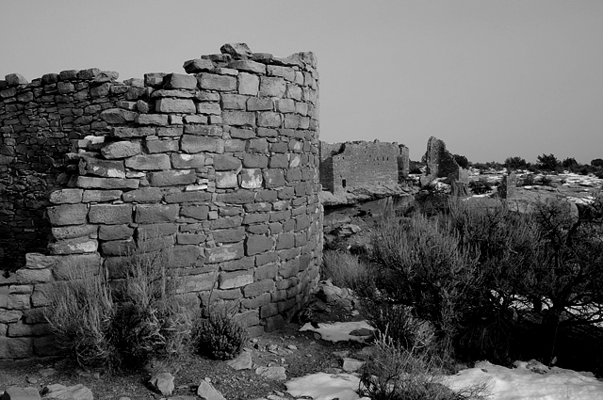  - Activity 2: Reading comprehension (CD2- track 22)  - Gives instructions  - Lets Ss listen to the recording  - Has Ss do the activity  - Checks answer  - Asks Ss to list the attractions mentioned in the article | - Respond to the T  Expected answer: an article  - Guess the topic of the article  Expected answer: attractions in Rome  - Respond to the T  - Listen to the T and take note new words.  - Listen to the T  - Listen to the recording  - Do the activity  - Check answers  Expected answers:  - about 20 kilometers  - mild and sunny  - sensational  - quite small  - on foot  - Respond to the T
25’ | Enjoying English: The goal of this section is to practice the language in the unit in an enjoyable, meaningful, and personalized way  - Activity 1:  - Elicits some activities people do on vacations  Ex: go to the beach, go swimming, play games…  - Focuses Ss’ attention on the pictures  - Has Ss do the activity 1  - Activity 2:  - Models the example conversation  - Lets Ss go around, asking and answering the questions  - Activity 3:  - Writes the model sentence on the board  - Has Ss report what they learn about other Ss | - Brainstorm adjectives and takes notes  - Identify the activities in the pictures  - Do the activity  - Do the activity  - Do the activity
30’ | Writing: The goal of this section is to practise writing a paragraph about things to do in the city  - Has Ss read the sample paragraph  - Elicits some useful structures  - Has Ss do the activity  - Asks some students write their work on the board and gives feedbacks | - Read the text  - Listen to the teacher  - Do the activity  - Show the work and correct

VIII. SUMMARY OF UNIT 1: 5 minutes
- T reminds Ss about:
+ the use of can and can’t
+ Useful language to talk about attractions in the city

IX. HOMEWORK:
- Ss have to do the workbook and prepare for the new lesson.

X. SELF-ASSESSMENT:
- The teaching methods are good because:
+ There are facilities and materials for students to study better.
+ The teacher’s preparation is careful.

Ngày tháng năm 201
THÔNG QUA TỔ BỘ MÔN Chữ ký giáo viên

NGUYỄN THỊ MINH QUÝ Trần Thanh Trúc

Subject: English 2  Lesson plan: 2  Date of teaching: Week 14/03/2016 | Time allowed: 7 periods | Total period taught: 7

UNIT 2: Is there a bank near here?

I. OBJECTIVES
By the end of the lesson, the students will be able to:
- Listen to tourists asking for information
- Talk about places
- Read an article about one of the biggest malls in the world
- Write about the street where you live
- Extend vocabulary about places around the town
- Learn the structure of there is/ there are
- Practise the linked sounds

II. METHOD
- Integrated, communicative oriented teaching approach.

III. TECHNIQUES
- Individual work
- Pair work.
- Group work.

IV. TEACHING AIDS
- Textbook.
- Black board, chalk.
- Pictures for teaching reading comprehension.
- Cassette player, amplifier, microphone.
- Pictures and hand-outs

V. PROCEDURE
- Greetings.
- Checking students’ attendance: 5 minutes
- Revision of the old lesson: 10 minutes
Can – Can’t: Ss work on their own to complete the exercise
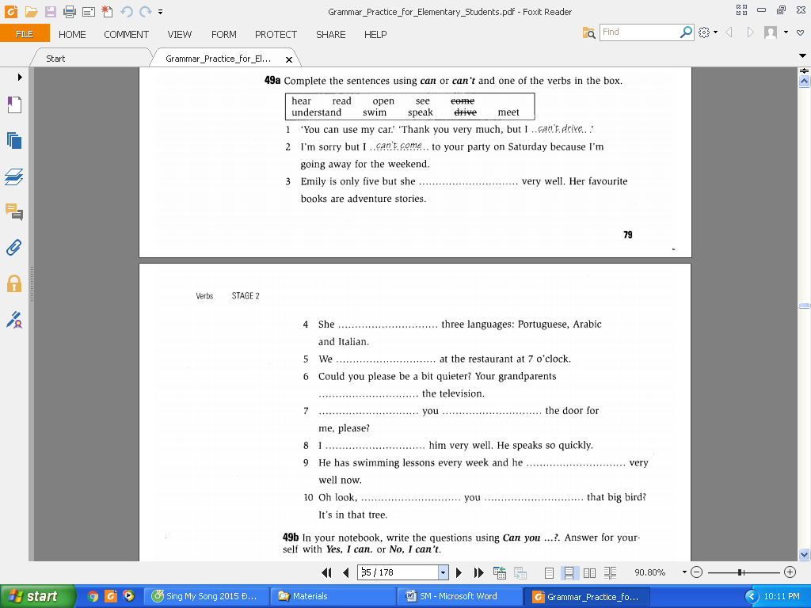

- New lesson.

 | Teacher | Students
20’ | Vocabulary: the goal of this section is to present and practice the target vocabulary of the unit  - Activity 1: Picture labeling  - Lets Ss play the picture-labeling game to review some places that Ss may know in English        - Explains the vocabulary items that Ss don’t know and has them do the activity.  - Activity 2: Listen and check (CD2-track 25)  - Plays the recording and checks the answers of activity 1  - Activity 3: Pair work  - Models the conversation  - Has Ss work in pair and do the activity  - Has pairs present their conversations | - Play the games  - Do the activity  - Listen and check the answers  Expected answer  1j – 2e – 3f – 4h – 5b  6c – 7g – 8a – 9i – 10d  - Listen to the T  - Do the activity  Expected answer  1g – 2e – 3a – 4b – 5c – 6d – 7f  - Present the conversations to the class
20’ | Conversation: the goal of this section is to present and practice the target vocabulary and grammar of the unit in a typical conversation  - Activity 1: Picture description  - Focuses Ss’ attention on the picture and asks some questions:  Who are the people?  Where are they?  What does the man want? …  - Activity 2: Listen and check(CD1-track 12)  - Focuses Ss’ attention on the model conversation  - Pre-teaches the words and phrases  neighborhood: using semantic map  downtown: using explanation  change some money: using example  - Has Ss do the activity  - Plays the recording and checks the answers  - Asks two Ss to model the conversation  - Has Ss practice in pairs  - Activity 3: Pair work  - Shows the examples and has Ss do the activity  - Activity 4: Free practice  - Elicits other examples of job titles and places  - Has Ss practise in pairs | - Listen to the T and answer the questions  - Listen to the T  - Do the activity  - Check the answers  Expected answers  1d – 2c – 3b – 4a  - Practise the conversation  - Do the activity  - Respond to the T  - Respond to the T  - Do the activity
70’ | Language Practice: the goal of this section is to present and practice the structure of “There is/ There are”  - Explain the rules  - Asks Ss to observe the examples in the book  - Elicits the meaning of the examples  - Elicits the use of “There is/ There are”  - Has Ss give examples to check understandings  - Activity 1: Completing the sentences  - Gives instructions and an example  - Has Ss do the activity  - Checks the answers  - Activity 2: Completing questions  - Gives instructions and an example  - Has Ss do the activity  - Checks the answers  - Activity 3: Pair work  - Models the example and give instructions  - Review the prepositions of place  - Has Ss work in pairs to make conversation  - Checks the Ss’ work and give feedback  - Workbook  - Has Ss do the workbook P.59-60-61 (SC1)  - Checks the answers | - Respond to the T  Expected answers:  There are: goes with plural object  There is: goes with singular object  - Listen to the T  - Do the activity  - Check answers  Expected answers:  - There’s  - There isn’t, there’s  - There isn’t  - There aren’t  - There’s, there aren’t  - There aren’t, there are  - Listen to the T  - Do the activity  - Check answers  Expected answers:  - Is there  - Is there  - Are there  - Are there  - Are there  - Is there  - Listen to the T  - Do the activity  - Listen to the T  - Do the workbook  - Check the answers
15’ | Pronunciation: the goal of this section to focus on the linked sounds  - Activity 1:Listen and repeat (CD2- track 28)  - Models the examples and has the Ss repeat  - Plays the recording and has Ss practice saying the examples  - Activity 2: Pair work  - Has Ss work in pairs and do the activity | - Listen to the T and repeat  - Listen and practise saying the examples  - Work in pairs and do the activity
40’ | Listening: The goal of this section is to practise listening selectively for key information  - Picture describing  - Focuses Ss’ attention on the pictures and asks them some questions:  Where is the man?  Who is the girl?  Where does the man want to go?...  - Has Ss guess the content of their conversations  - Listen and number (CD2-track 29)  - Gives instruction and focuses Ss’ attention on the key words  - Plays the recording and has Ss do the activity  - Checks the answers  - Listen and number (CD2-track 30)  - Gives instruction, focuses Ss’ attention on the chart, and elicits possible answers  - Plays the recording and has Ss do the activity  - Checks the answers | - Try to describe the pictures  - Guess the content of the conversations  - Listen to the T  - Do the activity  - Listen to the T & check the answers  Expected answers:  2 park – 3 shoe stores – 4 coffee shop  - Listen to the T  - Do the activity  - Listen to the T & check the answers  Expected answers:  1d – 2a – 3b – 4c
30’ | Smart Talk:  - Reviews vocabulary of places and prepositions of places (focus on pronunciation)  - Gives instructions and has Ss do the activity in pairs  - Gives feedback | - Listen and respond to the T  - Do the activity  - Listen to the T
40’ | Reading: the goal of this section is to practise reading comprehension  - Activity 1: Pre-reading  - Asks Ss to determine the form of the text  - Focuses Ss’ attention on the title and pictures of the mall.      - Asks Ss some questions:  Have you ever been in a shopping mall?  What are there in a shopping mall?  How large is it?  What can you do there?…  - Elicits related vocabulary  entertainment (n): using synonym  under one roof (n): using explanation  retail area(n): using explanation  on the planet (n): using synonym  airline package tour (n): using explanation  tunnel (n): using picture  - Activity 2: Reading comprehension (CD2- track 31)  - Gives instructions  - Lets Ss listen to the recording  - Has Ss do the activity  - Checks answer  - Let Ss answer some questions in the book  - Checks answer | - Respond to the T  Expected answer: an article  - Guess the topic of the article  Expected answer: things in a shopping mall  - Respond to the T  - Listen to the T and take note new words.  - Listen to the T  - Listen to the recording  - Do the activity  - Check answers  Expected answers:  - c – 2. a – 3. d – 4. b  - Do the activity  Expected answer:  - Seven nightclubs, an inside amusement park, an aquarium, and Camp Snoopy  - Walt Disney World and the Grand Canyon  - About 13,000 people work there in the summer  - In the underground tunnel  - Check answers
25’ | Enjoying English: The goal of this section is to practice the language in the unit in an enjoyable, meaningful, and personalized way  - Activity 1:  - Checks if Ss understand all the questions  - Has Ss do the activity 1 on their own  - Has Ss compare their answers  - Activity 2:  - Models the example conversation  - Lets Ss do the activity in group  - Activity 3:  - Writes the model sentence on the board  - Has Ss report what they learn about other Ss | - Respond to the T  - Do the activity  - Compare the answers together  - Do the activity  - Do the activity
30’ | Writing: The goal of this section is to practise writing a paragraph about the street where you live  - Has Ss read the sample paragraph  - Elicits some useful structures  - Has Ss do the activity  - Asks some students write their work on the board and gives feedbacks | - Fill in the form  - Listen to the teacher  - Do the activity  - Show the work and correct
VIII. SUMMARY OF UNIT 2: 5 minutes
- T reminds Ss about:
+ Vocabulary about places
+ there is and there are
IX. HOMEWORK:
- Ss have to do the workbook and prepare for the new lesson.
X. SELF-ASSESSMENT:
- The teaching methods are good because:
+ There are facilities and materials for students to study better.
+ The teacher’s preparation is careful.
XI. HAND-OUTS:

Ngày tháng năm 201
THÔNG QUA TỔ BỘ MÔN Chữ ký giáo viên

NGUYỄN THỊ MINH QUÝ Trần Thanh Trúc
Subject: English 2  Lesson plan: 3  Date of teaching: Week 28/03/2016 | Time allowed: 7 periods | Total period taught: 14

UNIT 3: Did you have a good time?

I. OBJECTIVES
By the end of the lesson, the students will be able to:
- Listen to stories about things that went wrong on vacation
- Talk about vacations
- Read about an ice hotel in Canada
- Write about your best (or worst) vacation
- Extend vocabulary about vacation activities
- Learn Simple Past tense
- Practise the final –ed sounds

II. METHOD
- Integrated, communicative oriented teaching approach.

III. TECHNIQUES
- Individual work
- Pair work.
- Group work.

IV. TEACHING AIDS
- Textbook.
- Black board, chalk.
- Cassette player, amplifier, microphone.
- Hand-outs for mini communication game

V. PROCEDURE
- Greetings.
- Checking students’ attendance: 5 minutes
- Revision of the old lesson: 10 minutes

There is/ are: T lets Ss play a mini communication game
Instructions:
The class is divided into two groups. Each group takes turn to make sentences using “There is/ are” in order to describe the classroom. The group which has more correct sentences will be the winner.

- New lesson.

 | Teacher | Students
20’ | Vocabulary: the goal of this section is to present and practice the target vocabulary of the unit  - Activity 1: Warm up and lead in  - Writes the word “vacation” on the board and elicits things that Ss usually do on their vacation.  - Activity 2: Match the phrases with the pictures  - Focuses Ss’ attention on the pictures and elicits what Ss have already known. (T may help Ss by asking guiding questions)  - Teaches some new words that Ss don’t know  Ex:  sunburn (n): using explanation  ocean(n) : using synonym  luggage (n):using picture    museum (n): using example  miss (v): using translation  climb (v): using example  break (n): using mime  postcard (n): using picture  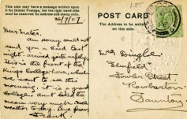  …  - Asks Ss to match the pictures with the phrases in the box  - Activity 3: Listen and check the answers  - Plays the recording and lets Ss check the answers  - Lets Ss practise saying the words  - Activity 4: Pair work  - Reviews adverbs of frequency  - Writes the sample dialogue on the board  - Models the dialogue  - Lets Ss work in pair and set the time limit  - Invites some pairs to speak up in front of the class  - Gives feedback | - Brainstorm ideas  - Answer the T’s questions and describe the pictures  - Listen to the T and take notes  - Do the activity  - Check the answers  Expected answer:  1h – 2b – 3a – 4f – 5g –  6c – 7d – 8e – 9j – 10i  - Repeat after the recording  - Listen and respond to the T  - Listen to the T  - Work in pair, asking and answering the questions  - Do the activity  - Listen to the T
20’ | Conversation: the goal of this section is to present and practice the target vocabulary and grammar of the unit in a typical conversation  - Activity 1: Describe the picture  - Focuses Ss’ attention on the picture and asks them some questions  What can you see in the picture?  Who are the two girls?  What are they doing?  What are they talking about?  What do we usually talk about vacations?  - Lead to the conversation  - Activity 2: Complete the conversation  - Focuses Ss’ attention on the conversation  - Pre-teaches some new words/ phrases  You look great! – thanks: using context  Tell me more! – No, it’s a secret: using context  awesome (adj): using synonym  have a good time: using explanation  - Lets Ss try to complete the conversation by themselves.  - Plays the recording and lets Ss check their answer  - Lets Ss practise the conversation in pairs  - Invites some pairs to demonstrate their work  - Gives feedback  - Activity 3: Pair work  - Shows the examples and has Ss do the activity  - Activity 4: Free practice  - Elicits other examples of food and invitation expressions  - Has Ss practise in pairs | - Look at the picture and answer the T’s questions  - Listen to the T  - Look at the conversation  - Listen and respond to the T  - Complete the conversation.  - Check the answer  Expected answer: 1b – 2a – 3c – 4d  - Practise the conversation  - Act out the conversation in front of the class  - Listen to the T  - Do the activity  - Do the activity
70’ | Language Practice: the goal of this section is to present and practice Simple Past  - Explain the rules  - Asks Ss what they like did and uses their ideas to make sample sentences in Simple past  - Gives the general form  (+) S + V_{ed}/ V₂+ …  (-) S + didn’t + V_{bare} + …  (?) Did + S + V_{bare} + …?  - Has Ss give some more examples to check understandings  - Activity 1: Complete the sentences  - Gives instructions and an example  - Has Ss do the activity  - Checks the answers  - Activity 2: Complete the questions  - Gives instructions and an example  - Has Ss do the activity  - Checks the answers  - Let Ss work in pair to ask and answer the questions  - Activity 3: Pair work  - Models the example and give instructions  - Has Ss write their own questions  - Has Ss work in pairs, ask and answer questions they have just written  - Checks the Ss’ work and give feedback  - Workbook:  - Has Ss do the workbook P.64-65-66 (SC1)  - Checks the answers | - Respond to the T  - Take notes  - Respond to the T  - Listen to the T  - Do the activity  - Check answers  Expected answers:  - met  - wrote  - flew, drove  - went, took  - made, lost  - Listen to the T  - Do the activity  - Check answers  Expected answers:  - Where did you go on your last vacation?  - How long did you stay there?  - Where did you stay?  - Did you do anything interesting?  - Did you meet anyone interesting?  - Do the activity  - Listen to the T  - Do the activity  - Listen to the T  - Do the workbook  - Check the answers
15’ | Pronunciation: the goal of this section to focus on the question intonation  - Activity 1:Listen and repeat (CD2- track35)  - Models the examples and has the Ss repeat  - Plays the recording and has Ss practice saying the examples  - Activity 2: Pair work (CD2- track36)  - Has Ss work in pairs and do the activity | - Listen to the T and repeat  - Listen and practise saying the examples  - Work in pairs and do the activity
35’ | Listening: The goal of this section is to practise listening selectively for key information  - Picture describing  - Focuses Ss’ attention on the pictures and elicits relating vocabulary  - Has Ss guess what the speakers will say  - Listen and number (CD1-track 37)  - Gives instruction and focuses Ss’ attention on the key words  - Plays the recording and has Ss do the activity  - Checks the answers  - Listen and number (CD1-track 38)  - Gives instruction, focuses Ss’ attention on the pictures  - Plays the recording and has Ss do the activity  - Checks the answers | - Try to describe the pictures  - Guess what the speakers will say  - Listen to the T  - Do the activity  - Listen to the T & check the answers  Expected answers:  Mexico City: 3  Rome: 2  Hong Kong: 1  - Listen to the T  - Do the activity  - Listen to the T & check the answers  Expected answers:  Hong Kong: No, He got a sunburn  Rome: Yes, The airline lost her luggage  Mexico city: No, He lost his passport
30’ | Smart Talk:  - Reviews the questions in Simple Past  - Gives instructions and has Ss do the activity in pairs  - Gives feedback | - Listen and respond to the T  - Do the activity  - Listen to the T
40’ | Reading: the goal of this section is to practise reading comprehension  - Activity 1: Pre-reading  - Focuses Ss’ attention on the title and pictures  - Explains the meaning of “ice hotel”  - Elicits related vocabulary  unique (adj): using explanation  temperature(n): using example  floor(n): using realia  ceiling (n): using realia  gallery(n): using explanation  skating rink (n): using picture  wedding chapel(n): using picture  glass(n): using picture  mattress(v): using picture  deer skin (v): using picture  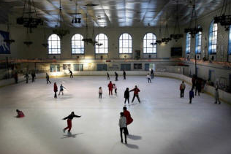    - Activity 2: Reading comprehension (CD2-Track 39)  - Gives instructions  - Has Ss listen to the recording  - Has Ss do the activity  - Checks answer | - Respond to the T  - Listen to the T and take note new words.  - Listen to the T  - Listen to the recording  - Do the activity  - Check answers  Expected answers:  - About 20 minutes west of Quebec city in Canada  - The difference is 24 degrees Celsius  - You can go to the art galleries, watch a movie, go skating, and get married.  - Four months  - More than 50,000 people
25’ | Enjoying English: The goal of this section is to practice the language in the unit in an enjoyable, meaningful, and personalized way  - Activity 1: Warm-up and lead-in  - Writes the phrase “Tom’s vacation at Panama Beach” and sticks the pictures of the trip on the board.                  - Elicits related vocabulary and structures  - Activity 2: Revision -Match the questions with the answers  - Delivers the handout  - Focuses Ss’ attention on the task and gives instructions  - Asks Ss to match the questions with the answers  - Corrects the exercise and emphasizes on the structure, especially Simple Past used in the answers  - Elicits other possible answers for the questions  - Activity 3: Think and write  - Asks Ss to think of their best vacation, write their answers in the chart  - Asks Ss to think of another question and write it in their book.  - Writes extra questions of Ss on the board and elicits possible answers  - Activity 4: Group work  - Lets Ss work in group of three, ask and answer the questions to complete the chart  - Invites some pairs to demonstrate their conversations  - Gives feedback  - Activity 5: Pair work  - Lets Ss work in pairs and tell their partners about the trip they are most interested in.  - Emphasizes that Ss can ask extra questions to get more information  - Invites some Ss to report their work  - Gives feedback | - Look at the board  - Respond to the teacher and brainstorm ideas  - Listen to the teacher  - Do the task  - Listen to the T and take notes  - Brainstorm idea  - Do the activity  - Do the activity  - Respond to the teacher  - Work in group to do the activity  - Demonstrate the conversations  - Listen to the teacher  - Do the activity  - Listen to the T  - Tell about the best vacation to the class  - Listen to the T
30’ | Writing: The goal of this section is to practise writing a paragraph about your best (worst) vacation  - Has Ss read the letter and answer the question:  Where did they go?  How did they go there?  What did they do?  What happened?...  - Has Ss do the activity based on the questions and structures  - Asks some students write their work on the board and gives feedbacks | - Answer the questions  - Do the activity  - Show the work and correct

VIII. SUMMARY OF UNIT 3: 5 minutes
- T reminds Ss about:
+ Vocabulary about vacations
+ Simple past
+ Useful language to talk about vacations

IX. HOMEWORK:
- Ss have to do the workbook and prepare for the new lesson.

X. SELF-ASSESSMENT:
- The teaching methods are good because:
+ There are facilities and materials for students to study better.
+ The teacher’s preparation is careful.
XI. HAND-OUTS:

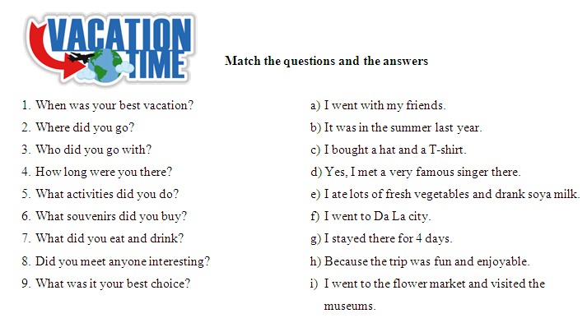

Ngày tháng năm 201
THÔNG QUA TỔ BỘ MÔN Chữ ký giáo viên

NGUYỄN THỊ MINH QUÝ Trần Thanh Trúc

Subject: English 2  Lesson plan: 4  Date of teaching: Week 11/04/2016 | Time allowed: 7 periods | Total period taught: 21

UNIT 4: I’m going to study law

I. OBJECTIVES
By the end of the lesson, the students will be able to:
- Listen to interviews about people’s jobs and future plans
- Talk about future plans
- Read about people who prepare to go abroad
- Write to someone who wants to study in another country
- Extend vocabulary about careers and schools
- Learn Going to + verb
- Practise pronunciation of “going to”

II. METHOD
- Integrated, communicative oriented teaching approach.

III. TECHNIQUES
- Individual work
- Pair work.
- Group work.

IV. TEACHING AIDS
- Textbook.
- Black board, chalk.
- Pictures for teaching vocabulary.
- Cassette player, amplifier, microphone.

V. PROCEDURE
- Greetings.
- Checking students’ attendance: 5 minutes
- Revision of the old lesson: 10 minutes
Simple past:

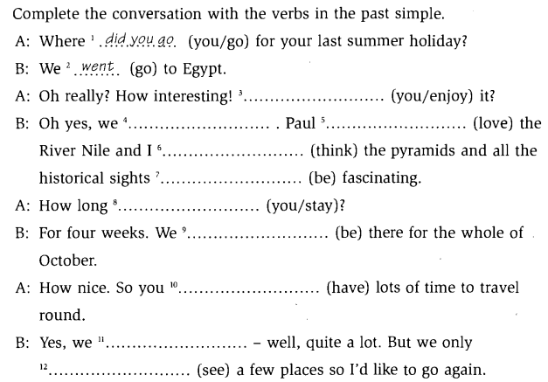

- New lesson.

 | Teacher | Students
20’ | Vocabulary: the goal of this section is to present and practice the target vocabulary of the unit  - Activity 1: Warm-up and lead-in  - Asks Ss what they would like to be in the future  - Activity 2: Match the phrases with the pictures  - Sticks the pictures on the board and elicits the careers of people in the pictures      - Teaches some new words about school in accordance with the careers  - Elicits some examples in real life  - Asks Ss to match the pictures with the phrases in the box  - Activity 3: Listen and check the answers  - Plays the recording and lets Ss check the answers  - Lets Ss practise saying the words  - Activity 4: Pair work  - Reviews the structure of can  - Writes the sample dialogue on the board  - Models the dialogue  - Lets Ss work in pair and set the time limit  - Invites some pairs to speak up in front of the class  - Gives feedback  - Activity 3:  - Delivers the handouts  - Lets Ss work in group to do the crosswords | - Brainstorm ideas  - Respond to the T  - Listen to the T and take notes  - Respond to the T  - Do the activity  - Check the answers  Expected answer:  1a – 2i – 3e – 4f – 5g –  6c – 7b – 8h – 9d  - Repeat the words  - Listen and respond to the T  - Listen to the T  - Work in pair, asking and answering the questions  - Do the activity  - Listen to the T  - Do the crosswords in group
20’ | Conversation: the goal of this section is to present and practice the target vocabulary and grammar of the unit in a typical conversation  - Activity 1: Picture description  - Focuses Ss’ attention on the picture and asks some questions:  What are the man talking about?  What jobs does he like?  Which one is his favorite?  - Elicits different kinds of jobs Ss know  - Activity 2: Listen and check (CD2-track 41)  - Focuses Ss’ attention on the model conversation  - Pre-teaches the words and phrases  rich (adj): using antonym  famous (adj): using example  give up (v): using explanation  - Has Ss do the activity  - Plays the recording and checks the answers  - Asks two Ss to model the conversation  - Has Ss practice in pairs  - Activity 3: Pair work  - Shows the examples and has Ss do the activity  - Activity 4: Free practice  - Elicits other examples of sports  - Has Ss practise in pairs | - Listen to the T and answer the questions  - Respond to the T  - Listen to the T  - Do the activity  - Check the answers  Expected answers  1a – 2d – 3b – 4c  - Practise the conversation  - Do the activity  - Do the activity  - Respond to the T  - Do the activity
70’ | Language Practice: the goal of this section is to present and practice “going to + Verb”  - Explain the rules  - Asks Ss what they are going to do next holiday, then uses their ideas to make sample sentences in Near Future tense  - Elicits the structure  - Has Ss give some more examples to check understandings  - Activity 1: Complete the sentences  - Gives instructions and an example  - Has Ss do the activity  - Checks the answers  - Activity 2: Complete the questions  - Gives instructions and an example  - Has Ss do the activity  - Checks the answers  - Activity 3: Pair work  - Models the example and give instructions  - Has Ss write their own conversations  - Has Ss work in pairs, asking and practicing their conversations  - Checks the Ss’ work and give feedback  - Workbook:  - Has Ss do the workbook P.69-70-71 (SC1)  - Checks the answers | - Respond to the T  Structure: “Be going to + V_{bare}”  - Respond to the T  - Listen to the T  - Do the activity  - Check answers  Expected answers:  - I’m going to be a pilot.  - She’s going to be a lawyer.  - He’s going to be a businessman.  - She’s going to be an actress.  - They’re going to be a directors.  - They’re going to be doctors.  - Listen to the T  - Do the activity  - Check answers  Expected answers:  - Is, going to study  - Are, going to eat  - Are, going to go  - Are, going to watch  - Is, going to do  - Are, going to work  - Listen to the T  - Do the activity  - Work in pairs  - Listen to the T  - Do the workbook  - Check the answers
15’ | Pronunciation: the goal of this section to focus on the sentence stress  - Activity 1:Listen and repeat (CD2 – track 43)  - Models the examples and has the Ss repeat  - Plays the recording and has Ss practice saying the examples  - Activity 2: Pair work  - Has Ss work in pairs and do the activity | - Listen to the T and repeat  - Listen and practise saying the examples  - Work in pairs and do the activity
35’ | Listening: The goal of this section is to practise listening selectively for key information  - Picture describing  - Focuses Ss’ attention on the pictures and encourages Ss to describe what they see  - Pre-teaches new words  hotel clerk(n): using explanation  college (n): using example  save money (n): using explanation  - Listen and number (CD2-track 44)  - Gives instruction and focuses Ss’ attention on the key words  - Plays the recording and has Ss do the activity  - Checks the answers  - Listen and complete the chart (CD2-track 45)  - Gives instruction, focuses Ss’ attention on 4 kinds of information: name, age, activity, frequency  - Plays the recording and has Ss do the activity  - Checks the answers | - Try to describe the pictures  - Listen to the T and take notes  - Listen to the T  - Do the activity  - Listen to the T & check the answers  Expected answers:  - hates it – 2. loves it – 3. Likes it  - Listen to the T  - Do the activity  - Listen to the T & check the answers  Expected answers:  - Julia – 2. Gina – 3.Julia – 4. Don –5. Gina – 6. Don
30’ | Smart Talk:  - Reviews useful structure  Are you going to …?  What are you going to…?  - Gives instructions and has Ss do the activity in pairs  - Gives feedback | - Listen and respond to the T  - Do the activity  - Listen to the T
40’ | Reading: the goal of this section is to practise reading comprehension  - Activity 1: Pre-reading  - Asks Ss to determine the form of the text  - Focuses Ss’ attention on the title  - Asks Ss some questions:  Are you going to study in another country?  If yes, which country are you going to go to?  - Elicits related vocabulary  expensive(adj): using antonym  in common (n): using explanation  worried (adj): using explanation  electronics company (n): using translation  degree(n): using synonym  major(n): using example  age(n): using example  - Activity 2: Reading comprehension (CD2- track 46)  - Gives instructions  - Lets Ss listen to the recording  - Has Ss do the activity  - Checks answer  - Activity 3: Reading comprehension  - Gives instructions  - Has Ss do the activity  - Checks answer | - Respond to the T  - Listen to the T and take note new words.  - Listen to the T  - Listen to the recording  - Do the activity  - Check answers  Expected answers:  - Taipei, Taiwan, 22, law  - Osaka, Japan, 24, business  - Recife, Brazil, 25, computers  - Listen to the T  - Do the activity  - Check answers  Expected answers:  1T – 2F – 3T – 4T  5F – 6T – 7T – 8T
25’ | Enjoying English: The goal of this section is to practice the language in the unit in an enjoyable, meaningful, and personalized way  - Activity 1: Pair work  - Focuses Ss’ attention on the pictures and asks if Ss know the two people  - Lets Ss to work in pairs to do the activity  - Checks the answer  - Activity 2:  - Models the example  - Lets Ss get onto groups, writing their statements  - Activity 3:  - Has each group present its statements  - Has others group guess which statement is false | - Brainstorm and take notes  - Do the activity  Expected answers:  Zhang Ziyi: statement 3  David Beckham: statement 3  - Listen to the T  - Do the activity  - Present in front of the class  - Join in the activity
30’ | Writing: The goal of this section is to practise writing a paragraph about oneself  - Has Ss read the email  - Has Ss write their own email  - Asks some students write their work on the board and gives feedbacks | - Answer the questions  - Do the activity  - Show the work and correct

VIII. SUMMARY OF UNIT 4: 5 minutes
- T reminds Ss about:
+ Vocabulary about careers and schools
+ be going to + VERB
+ Useful language to ask and answer about future plans

IX. HOMEWORK:
- Ss have to do the workbook and prepare for the new lesson.

X. SELF-ASSESSMENT:
- The teaching methods are good because:
+ There are facilities and materials for students to study better.
+ The teacher’s preparation is careful.

IX. HAND-OUTS

 |  |  |  |  |  |  |  | 8
 |  |  |  | 6 |  |  |  | M | 10 |  |  |  |  | ACROSS
 |  |  |  | D |  |  |  | U | A |  |  |  |  | - He designs and builds houses. He is an _____.
 |  |  |  | R |  | 7 |  | S | C |  |  |  |  | - Most actors and actresses studied in a _____ school.
 |  |  | 1 | A | R | C | H | I | T | E | C | T |  | - She is a hairdresser. She studied in a _____ school.
2 | F | I | L | M |  | A |  | C | O |  |  |  |  | - He studied law. He is a _____.
 |  |  |  | A |  | R |  | 9 | R |  |  |  |  | - He looks after people’s teeth. He’s a _____.
 |  |  |  |  |  | E |  | B
 |  |  |  | 3 | B | E | A | U | T | Y |  |  |  | DOWN
4 | L | A | W | Y | E | R |  | S |  |  |  |  |  | - Thành Lộc is a famous _____ actor in Vietnam.
 |  |  |  |  |  |  |  | I |  |  |  |  |  | - It means jobs. It’s “_____”
 |  |  |  |  |  |  |  | N |  |  |  |  |  | - She can play _____ on piano.
 |  |  |  |  |  |  |  | E |  |  |  |  |  | - She is a businesswoman. She studied in _____ school.
 |  | 5 | D | E | N | T | I | S | T |  |  |  |  | - He’s the person who plays a role in films. He’s an _____.
 |  |  |  |  |  |  |  | S

Ngày tháng năm 201

THÔNG QUA TỔ BỘ MÔN Chữ ký giáo viên

NGUYỄN THỊ MINH QUÝ Trần Thanh Trúc

Subject: English 2  Lesson plan: 5  Date of teaching: Week 25/04/2016 | Time allowed: 2 periods | Total period taught: 28

Review: Unit 1-4

I. OBJECTIVES
This unit aims to review:
- Vocabulary: Units 1-4
- Grammar: can/ can’t – there is/are – Simple Past – be going to
- Listening: Listening comprension skill
- Reading: Reading comprension skill

II. METHOD
- Integrated, communicative oriented teaching approach.

III. TECHNIQUES
- Individual work
- Pair work.
- Group work.

IV. TEACHING AIDS
- Textbook.
- Black board, chalk.
- Cassette player, amplifier, microphone.

V. PROCEDURE
- Greetings.
- Checking students’ attendance: 5 minutes
- Revision of the old lesson: 10 minutes
Food and drink: T lets Ss complete the exercise.

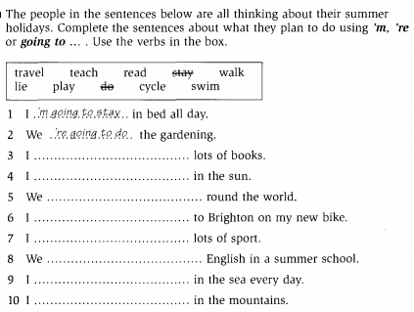

- New lesson.

 | Teacher | Students
10’ | Song: the goal of this section is to review the language presented in Unit 1-3  - Activity 1: Pre-listening  - Focus Ss’ attention on the picture and asks Ss some questions:  What do you do when they can’t sleep?  What do people do when they can’t sleep?  - Elicits some vocabulary  sky (n): using realia  sunrise (n): using explanation  sound (n): using explanation  bark (v) : using example  - Activity 2: While-listening (CD2 – track 47)  - Plays the recording  - Has Ss to fill in the blanks | - Respond to the T  - Listen to the recording  - Do the activity  Expected answers  - woke up  - got up  - went out  - walked  - saw  - stood  - watched  - rose  - listened  - drove  - were  - dreamed
20’ | Story: the goal of this section is to review and practice the language presented in Unit 1-3 in a fun way  - Activity 1:  - Focuses Ss’ attention on the comic strip and asks some questions:  Where are people?  - Pre-teaches some new words  Fitness center (n): using explanation  nightclub (n): using explanation  - Activity 2: (CD2 – track 48)  - Focuses Ss’ attention on the blanks and the answers choice  - Model the first one as an example  - Has Ss do the activity  - Plays the recording and checks the answers  - Activity 3: Pair work  - Asks two Ss to model the conversation  - Has Ss practice in pairs  - Activity 4: Free practice  - Shows the examples and has Ss do the activity  - Has Ss perform in front of the class  - Activity 5: Workbook  - Has Ss do the workbook P.73-76 (SC1) | - Listen to the T and answer the questions  - Listen to the T and take notes  - Listen to the T  - Listen to the T  - Do the activity  - Check the answers  Expected answers  1c– 2b – 3a – 4e – 5d – 6 I slept!  - Practise the conversation  - Do the activity  - Do the activity using their ideas  - Perform in front of the class
45’ | One-period Test 1

VIII. SUMMARY: 5 minutes
- T reminds Ss about main content of the lesson

IX. HOMEWORK:
- Ss have to do the workbook and prepare for the new lesson.

X. SELF-ASSESSMENT:
- The teaching methods are good because:
+ There are facilities and materials for students to study better.
+ The teacher’s preparation is careful.

Ngày tháng năm 201
THÔNG QUA TỔ BỘ MÔN Chữ ký giáo viên

NGUYỄN THỊ MINH QUÝ Trần Thanh Trúc

Subject: English 2  Lesson plan: 6  Date of teaching: Week 25/04/2016 | Time allowed: 7 periods | Total period taught: 30

UNIT 5: How was your vacation?

I. OBJECTIVES
By the end of the lesson, the students will be able to:
- Listen to phone conversations
- Talk about vacations
- Read an article about mountain climbing for charity
- Write about your likes or dislikes
- Extend vocabulary about places to go and things to do
- Learn to express agreement and disagreement
- Practise the sentence stress

II. METHOD
- Integrated, communicative oriented teaching approach.

III. TECHNIQUES
- Individual work
- Pair work.
- Group work.

IV. TEACHING AIDS
- Textbook.
- Black board, chalk.
- Cassette player, amplifier, microphone.
- Pictures and hand-outs

V. PROCEDURE
- Greetings.
- Checking students’ attendance: 5 minutes
- Revision of the old lesson: 10 minutes
Be going to V
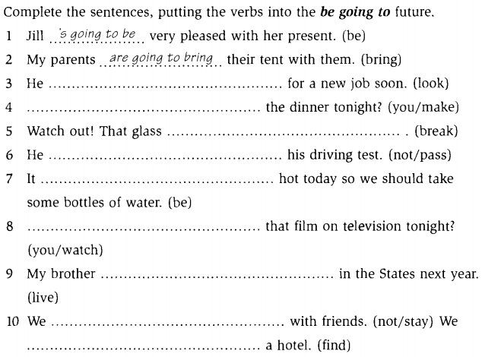

- New lesson.

 | Teacher | Students
20’ | Vocabulary: the goal of this section is to present and practice the target vocabulary of the unit  - Activity 1: Put the word in the correct list  - Focuses Ss’ attention on the words in the box and elicits the ones they have already known  - Teaches Ss some new words such as  jungle (n): using picture    tropical island (n): using picture    desert (n): using example  go on safari: using picture    - Has Ss do the activity  - Activity 2: Listen and check (CD1-track 4)  - Plays the recording and checks the answers of activity 1  - Activity 3: Pair work  - Models the conversation  - Draws Ss’ attention on the use of Simple Past  - Has Ss work in pair and do the activity  - Has pairs present their conversations | - Respond to the T  - Listen to the T  - Do the activity  - Listen and check the answers  Expected answer  Places to go : e, g, h, j, k, n  Things to do: d, e, f, i, l, m  - Listen to the T  - Do the activity  - Present the conversations to the class
20’ | Conversation: the goal of this section is to present and practice the target vocabulary and grammar of the unit in a typical conversation  - Activity 1: Picture description  - Focuses Ss’ attention on the picture and asks some questions:  Who are the people?  Where are they?  Do they know each other? …  - Activity 2: Listen and check (CD1-track 5)  - Focuses Ss’ attention on the model conversation  - Pre-teaches the words and phrases  No way! : using context  - Has Ss do the activity  - Plays the recording and checks the answers  - Asks two Ss to model the conversation  - Has Ss practice in pairs  - Activity 3: Pair work  - Shows the examples and has Ss do the activity  - Activity 4: Free practice  - Elicits other examples of job titles and places  - Has Ss practise in pairs | - Listen to the T and answer the questions  - Listen to the T  - Do the activity  - Check the answers  Expected answers  1d – 2b – 3c – 4a  - Practise the conversation  - Do the activity  - Respond to the T  - Do the activity
70’ | Language Practice: the goal of this section is to present and practice Agreeing and Disagreeing  - Explain the rules  - Writes some examples on the board to contrast Agreeing and Disagreeing  Ex: We study every day.  So do we/ Really, we don’t.  - Elicits the examples in different tenses  - Activity 1: Match the statements and responses  - Gives instructions and an example  - Has Ss do the activity  - Checks the answers  - Activity 2: Completing conversations  - Gives instructions and an example  - Has Ss do the activity  - Checks the answers  - Activity 3: Pair work  - Models the example and give instructions  - Has Ss work in pairs to do the activity  - Checks the Ss’ work and give feedback  - Workbook  - Has Ss do the workbook P.2-3(SC2)  - Checks the answers | - Respond to the T  - Play the games  - Listen to the T  - Do the activity  - Check answers  Expected answers:  1e – 2c – 3a – 4f – 5b – 6d  - Listen to the T  - Do the activity  - Check answers  Expected answers:  - So do I  - Well I did  - Really I don’t  - Neither do I  - Neither can I  - I’m not  - Listen to the T  - Do the activity  - Listen to the T  - Do the workbook  - Check the answers
15’ | Pronunciation: the goal of this section to focus on the sentence stress  - Activity 1:Listen and repeat (CD1- track 7)  - Models the examples and has the Ss repeat  - Plays the recording and has Ss practice saying the examples  - Activity 2: Pair work  - Has Ss work in pairs and do the activity | - Listen to the T and repeat  - Listen and practise saying the examples  - Work in pairs and do the activity
40’ | Listening: The goal of this section is to practise listening selectively for key information  - Picture describing  - Focuses Ss’ attention on the pictures and encourages Ss to guess what they are talking about:  - Listen and complete the chart (CD1-track 8)  - Gives instruction and focuses Ss’ attention on the key words  - Plays the recording and has Ss do the activity  - Checks the answers  - Listen and check T or F (CD1-track 9)  - Gives instruction and focuses Ss’ attention on the key words  - Plays the recording and has Ss do the activity  - Checks the answers | - Try to describe the pictures  - Listen to the T  - Do the activity  - Listen to the T & check the answers  Expected answers:  2Joanne – 3Joanne – 4 Tom – 5 Joanne  - Listen to the T  - Do the activity  - Listen to the T & check the answers  Expected answers:  1T – 2F – 3F – 4F
30’ | Smart Talk:  - Reviews vocabulary about personalities (focus on pronunciation)  - Gives instructions and has Ss fill in the YOU column by themselves  - Lets Ss work in pair to do the activity  - Asks some pairs to present their work and gives feedback | - Listen and respond to the T  - Do the activity  - Do the activity  - Present in front of the class
40’ | Reading: the goal of this section is to practise reading comprehension  - Activity 1: Pre-reading  - Asks Ss some questions about Ss’ vacations  Ex: What can you do on vacations?  - Focuses Ss’ attention on the picture and asks them “What do the people do on their vacation?”  - Pre-teaches new vocabulary  peak (v): using drawing  challenge (n): using translation  raise money: using example  charity: using explanation  exhausted(adj): using synonym  agree to (v): using synonym  - Activity 2: Reading comprehension (CD1- track 10)  - Gives instructions  - Lets Ss listen to the recording  - Has Ss do the activity  - Checks answer  - Lets Ss summarize the vacation in three categories  + mountain  +location  + weather  +feelings  - Activity 3: Post-reading  - Focuses Ss’ attention on the questions- Lets Ss work in group and discuss the | - Respond to the T  - Respond to the T  - Listen to the T and take note new words.  - Listen to the T  - Listen to the recording  - Do the activity  - Check answers  Expected answers:  - Andy  - Crazy  - Exhausted  - Happy  - $1000  - Do the activity  - Listen and respond to the T  - Work in group and discuss
25’ | Enjoying English: The goal of this section is to practice the language in the unit in an enjoyable, meaningful, and personalized way  - Activity 1:  - Focuses Ss’ attention on the pictures  - Has Ss do the activity 1 on their own  - Activity 2:  - Models the example conversation and elicits some answers to questions from individual Ss.  - Lets Ss work in group  - Activity 3:  - Invites Some Ss to report the group discussion | - Brainstorm activities  - Do the activity  - Listen and respond to the T  - Do the activity  - Do the activity
30’ | Writing: The goal of this section is to practise writing an online conversation  - Has Ss complete the online conversation  - Reviews some useful structures to express agreement or disagreement  - Has Sodom the activity  - Asks some students exchange their work and write the responses to their friend’s email | - Fill in the form  - Listen to the teacher  - Do the activity

VIII. SUMMARY OF UNIT 5: 5 minutes
- T reminds Ss about:
+ Vocabulary about places to go and things to do
+ Agreeing and disagreeing
+ Useful language of talking about vacations

IX. HOMEWORK:
- Ss have to do the workbook and prepare for the new lesson.

X. SELF-ASSESSMENT:
- The teaching methods are good because:
+ There are facilities and materials for students to study better.
+ The teacher’s preparation is careful.
XI. HAND-OUTS:

Ngày tháng năm 201
THÔNG QUA TỔ BỘ MÔN Chữ ký giáo viên

NGUYỄN THỊ MINH QUÝ Trần Thanh Trúc

Subject: English 2  Lesson plan: 7  Date of teaching: Week 09/05/2016 | Time allowed: 7 periods | Total period taught: 37

UNIT 6: Where were you yesterday?

I. OBJECTIVES
By the end of the lesson, the students will be able to:
- Listen to people talking about why they were late
- Give opinions about movies and music
- Read an article about people’s opinions about the cost of hit movies
- Write to a pen pal in another country.
- Extend vocabulary about movies and music
- Learn adjectives with –ing and -ed
- Practise syllable stress

II. METHOD
- Integrated, communicative oriented teaching approach.

III. TECHNIQUES
- Individual work
- Pair work.
- Group work.

IV. TEACHING AIDS
- Textbook.
- Black board, chalk.
- Cassette player, amplifier, microphone.
- Hand-outs to review old lesson.

V. PROCEDURE
- Greetings.
- Checking students’ attendance: 5 minutes
- Revision of the old lesson: 10 minutes
Agreeing and disagreeing: T lets Ss fill in the questionnaire and then work in pair to practise expressing their agreement or disagreement.
 | YOU | YOUR PARTNER
What food do you like best?
What food don’t you like best?
What do you do after school?
What did you do yesterday?
What are you going to do this summer?

- New lesson.

 | Teacher | Students
20’ | Vocabulary: the goal of this section is to present and practice the target vocabulary of the unit  - Activity 1: put the words in the box in the correct list  - Focuses Ss’ attention on the words in the box and checks to see which ones Ss already know  - Explains the vocabulary items that Ss don’t know by giving examples of some well-known movies and songs  * Movies:    Action movie martial arts movie  animation    science fiction – horror – romantic comedy  * Songs  https://www.youtube.com/watch?v=iKdZbI4NU2g  https://www.youtube.com/watch?v=7uxF9CsxW88  https://www.youtube.com/watch?v=g3GhDWMb_3E  - Has them do the activity.  - Activity 2: Listen and check (CD1-track 11)  - Plays the recording and checks the answers of activity 1.  - Activity 3: Pair work  - Draws Ss’ attention on the conversation and makes a dry-run  - Has Ss work in pair and do the activity  - Has pairs present their conversation | - Listen to the T  - Do the activity  - Listen and check the answers  Expected answer  - Kinds of movie: a, c, d, e, h, j  - Kinds of music: b, f, g, i, k, l  - Listen to the T  - Do the activity  - Present the story to the class
20’ | Conversation: the goal of this section is to present and practice the target vocabulary and grammar of the unit in a typical conversation  - Activity 1: Picture description  - Focuses Ss’ attention on the picture and asks some questions:  Who are the people?  Where are they?  What are they saying?  - Activity 2: Listen and check (CD1-track 12)  - Focuses Ss’ attention on the model conversation  - Pre-teaches the words and phrases  Can’t stand: using context  - Has Ss do the activity  - Plays the recording and checks the answers  - Asks two Ss to model the conversation  - Has Ss practice in pairs  - Activity 3: Pair work  - Shows the examples and has Ss do the activity  - Activity 4: Free practice  - Elicits other examples of job titles and places  - Has Ss practise in pairs | - Listen to the T and answer the questions  - Listen to the T  - Do the activity  - Check the answers  Expected answers  1a – 2b – 3d – 4c  - Practise the conversation  - Do the activity  - Respond to the T  - Do the activity
70’ | Language Practice: the goal of this section is to present and practice using adjectives with –ing or -ed  - Explain the rules  - Provides Ss with some examples  Ex:  The story is interesting. I am interested in it.  - Elicits the meaning of the examples  - Has Ss give examples to check understandings  - Activity 1: Completing sentences  - Gives instructions and an example  - Has Ss do the activity  - Checks the answers  - Activity 2: Writing opinions about these things  - Gives instructions and an example  - Has Ss do the activity  - Gives feedback  - Activity 3: Pair work  - Models the example and give instructions  - Has Ss work in pairs to complete the sentences  - Checks the Ss’ work and gives feedback  - Workbook  - Has Ss do the workbook P.7-8 (SC2)  - Checks the answers | - Respond to the T  Expected answers:  -ing:  -ed: being affected by sth  - Listen to the T and take notes  - Listen to the T  - Do the activity  - Check answers  Expected answers:  - disappointing – disappointed  - amazing – amazed  - tired – tiring  - disappointed – disappointing  - surprised – surprising  - boring – bored  - Listen to the T  - Do the activity  - Listen to the T  - Listen to the T  - Do the activity  - Listen to the T  - Do the workbook  - Check the answers
15’ | Pronunciation: the goal of this section to focus on the reduced form of “was, wasn’t, were, weren’t”  - Activity 1:Listen and repeat (CD1- track 14)  - Models the examples and has the Ss repeat  - Plays the recording and has Ss practice saying the examples  - Activity 2: Add the words to the correct column (CD1- track 15)  - Has Ss do the activity | - Listen to the T and repeat  - Listen and practise saying the examples  - Do the activity
40’ | Listening: The goal of this section is to practise listening selectively for key information  - Picture describing  - Focuses Ss’ attention on the pictures and elicits relating vocabulary  - Has Ss guess the content of their conversations  Where are they?  What are their jobs?  What are they doing?  - Listen and complete the chart (CD1-track 16)  - Gives instruction and focuses Ss’ attention on the key words  - Plays the recording and has Ss do the activity  - Checks the answers  - Listen and answer the questions (CD1-track 17)  - Gives instruction, focuses Ss’ attention on the options  - Plays the recording and has Ss do the activity  - Checks the answers | - Try to describe the pictures  - Guess the content of the conversations  - Listen to the T  - Do the activity  - Listen to the T & check the answers  Expected answers:  Karen – Chicago – law student – stay home, watch DVD  Paul – New York – business student – chat, go online  Emi – Taipei – actress – listen to music  - Listen to the T  - Do the activity  - Listen to the T & check the answers  Expected answers:  - exhausted  - amazing  - relaxing  - interesting  - tiring  - peaceful, calm
30’ | Smart Talk:  - Review vocabulary (focus on pronunciation)  live concert (n)  hang out (v)  theater (n)  - Gives instructions and has Ss do the activity in pairs  - Gives feedback | - Listen and respond to the T  - Do the activity  - Listen to the T
40’ | Reading: the goal of this section is to practise reading comprehension  - Activity 1: Pre-reading  - Asks Ss to determine the form of the text  - Focuses Ss’ attention on the title and pictures and lets Ss guess the topic of the article.  - Asks Ss some questions:  Do you ever watch any hit movies?  Do you like them?  Do you think they’re worth the money?  - Elicits related vocabulary  successful(adj): using explanation  script (n): using explanation  acting (n): using explanation  scenery(n): using explanation  battle scene (n): using explanation  starfighter(v): using picture    special effect(v): using example  line (n):using explanation  energy (n):using explanation  - Activity 2: Reading comprehension (CD1- track 18)  - Gives instructions and trains Ss to guess meaning according to the context  - Lets Ss listen to the recording  - Has Ss do the activity  - Checks answer | - Respond to the T  Expected answer: an article  - Guess the topic of the article  Expected answer: films  - Respond to the T  - Listen to the T and take note new words.  - Listen to the T  - Listen to the recording  - Do the activity  - Check answers  Expected answers:  1e – 2d – 3f – 4c – 5a – 6b
25’ | Enjoying English: The goal of this section is to practice the language in the unit in an enjoyable, meaningful, and personalized way  - Activity 1:  - Focuses Ss’ attention on the survey and has Ss fill in it  - Activity 2:  - Models the example conversation  - Lets Ss work in group, comparing their answers  - Gives feedback | - Do the activity  - Do the activity  - Listen to the Ss
30’ | Writing: The goal of this section is to practise writing a paragraph about oneself  - Has Ss read the letter and checks their understandings  What’s the writer’s name?  Where is he studying?  What’s he studying?  How is his hometown?  What do people do in their free time there?  - Has Ss do the activity using the questions as an guide  - Asks some students write their work on the board and gives feedbacks | - Read the letter and answer the questions  - Do the activity  - Show the work and correct

VIII. SUMMARY OF UNIT 6: 5 minutes
- T reminds Ss about:
+ Vocabulary
+ Adjectives with –ing or -ed
+ Useful language of movies and music

IX. HOMEWORK:
- Ss have to do the workbook and prepare for the new lesson.

X. SELF-ASSESSMENT:
- The teaching methods are good because:
+ There are facilities and materials for students to study better.
+ The teacher’s preparation is careful.

Ngày tháng năm 201
THÔNG QUA TỔ BỘ MÔN Chữ ký giáo viên

NGUYỄN THỊ MINH QUÝ Trần Thanh Trúc

Subject: English 2  Lesson plan:8  Date of teaching: Week 23/05/2016 | Time allowed: 7 periods | Total period taught: 44

UNIT 7: Do it before you’re 30?

I. OBJECTIVES
By the end of the lesson, the students will be able to:
- Listen to interviews with world class athletes
- Talk about experiences
- Read an article about an extreme sport legend
- Write a celebrity interview
- Extend vocabulary about extreme sports and activities
- Learn Present Perfect
- Practise Linked sounds

II. METHOD
- Integrated, communicative oriented teaching approach.

III. TECHNIQUES
- Individual work
- Pair work.
- Group work.

IV. TEACHING AIDS
- Textbook.
- Black board, chalk.
- Cassette player, amplifier, microphone.
- Pictures and hand-outs

V. PROCEDURE
- Greetings.
- Checking students’ attendance: 5 minutes
- Revision of the old lesson: 10 minutes
Adjectives with – ing / -ed: T lets Ss do the exercise in pairs
- I do the same thing every day. My job is very ______ . (bore)
- I have nothing to do. I'm ______ .(bore)
- My job is very varied. I find it ______ . (excite)
- I'm ______ in applying for the job. (interest)
- I heard some very ______ news. I'm going to lose my job. I feel terrible (disappoint)
- Cheer up . Don't feel so ______ . There are plenty of other jobs. (disappoint)
- I heard a very ______ story. It will make you laugh. (amaze)
- It's not ______ that you failed the exam. You never did any work. (surprise)
- My trip to Paris has been cancelled. I'm really ______ . I really wanted to go. (disappoint)
- I was ______ at the news. I didn't expect it. (amazed)

- New lesson.

 | Teacher | Students
20’ | Vocabulary: the goal of this section is to present and practice the target vocabulary of the unit  - Activity 1: Checking the box (CD1 – track 19)  - Focuses Ss’ attention on the pictures and checks to see which ones Ss already know  - Explains the vocabulary items that Ss don’t know and has them do the activity.  Bungee jumping  Flying a plane  Running a marathon   Parasailing   Climbing a mountain   Kayaking   Skiing   Rock climbing 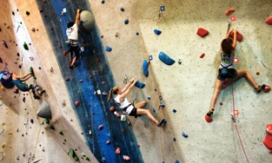  Driving a racecar   Riding a motorcycle   Skydiving   Windsurfing   - Plays the recording and checks the pronunciation of the words  - Activity 2: Pair work  - Models the conversation and draws Ss’ attention on the activities that are underlined in the conversation  - Has Ss work in pair and do the activity  - Has pairs present their conversation | - Listen to the T  - Do the activity  - Listen  - Listen to the T  - Do the activity  - Present the conversation to the class
20’ | Conversation: the goal of this section is to present and practice the target vocabulary and grammar of the unit in a typical conversation  - Activity 1: Picture description  - Focuses Ss’ attention on the picture and asks some questions:  Who are the people?  Where are they?  What are they doing?  - Activity 2: Listen and check (CD1-track 20)  - Focuses Ss’ attention on the model conversation  - Has Ss do the activity  - Plays the recording and checks the answers  - Asks two Ss to model the conversation  - Has Ss practice in pairs  - Activity 3: Pair work  - Shows the examples and has Ss do the activity  - Activity 4: Free practice  - Elicits other examples of job titles and places  - Has Ss practise in pairs | - Listen to the T and answer the questions  - Listen to the T  - Do the activity  - Check the answers  Expected answers  1c – 2b – 3d – 4a  - Practise the conversation  - Do the activity  - Respond to the T  - Do the activity
70’ | Language Practice: the goal of this section is to present and practice Comparatives  - Explain the rules  - Provides Ss with some examples  Ex:  Have you ever eaten pizza?  I haven’t tried bungee jumping.  Nam has ridden a motorcycle  - Elicits the meaning of the examples  - Elicits the form and use of Present Perfect  - Has Ss give examples to check understandings  - Makes notes on some special signals of the tense: already, just, ever, never, since, for,…  - Activity 1: Completing conversations  - Gives instructions and an example  - Has Ss do the activity  - Checks the answers  - Activity 2: Writing sentences about you  - Gives instructions and an example  - Has Ss do the activity  - Gives feedback  - Activity 3: Pair work  - Models the example and give instructions  - Has Ss work in pairs to ask and answer the questions  - Checks the Ss’ work and gives feedback  - Workbook  - Has Ss do the workbook P.12-13 (SC2)  - Checks the answers | - Listen to the T and take notes  - Respond to the T  Expected answer:  (+) S + have/ has + V_{3/ed}…  (-) S + have/ has + not + V_{3/ed}…  (?) Have/ has + S + V_{3/ed}…?  - Listen to the T and take notes  - Listen to the T and take notes  - Listen to the T  - Do the activity  - Check answers  Expected answers:  - eaten  have – tried  - gone – have – went  - met – haven’t  - run – ran  - Listen to the T  - Do the activity  - Listen to the T  - Listen to the T  - Do the activity  - Presents the work in front of the class  - Do the workbook  - Check the answers
15’ | Pronunciation: the goal of this section to focus on the sentence stress  - Activity 1:Listen and repeat (CD1- track 22)  - Models the examples and has the Ss repeat  - Plays the recording and has Ss practice saying the examples  - Activity 2: Pair work  - Has Ss work in pairs and do the activity | - Listen to the T and repeat  - Listen and practise saying the examples  - Work in pairs and do the activity
40’ | Listening: The goal of this section is to practise listening selectively for key information  - Activity 1: Picture describing  - Focuses Ss’ attention on the pictures and elicits relating vocabulary:  hand gliding (n)  triathlon (n)  freestyle skiing (n)  accident (n)  champion (n)  record (n)  - Has Ss raise their background knowledge about those sports  - Activity 2: Listen and number (CD1-track 23)  - Gives instruction and focuses Ss’ attention on the key words  - Plays the recording and has Ss do the activity  - Checks the answers  - Activity 3: Listen and decide True or False (CD1-track 24)  - Gives instruction, focuses Ss’ attention on the options  - Plays the recording and has Ss do the activity  - Checks the answers | - Try to describe the pictures  - Respond to the T  - Listen to the T  - Do the activity  - Listen to the T & check the answers  Expected answers:  Barbara – hang gliding – no  Victor – freestyle skiing – yes – broken arm/ leg  Lucy – triathlon – yes – broken hand  - Listen to the T  - Do the activity  - Listen to the T & check the answers  Expected answers:  1T – 2F – 3F – 4F – 5T – 6T
30’ | Smart Talk:  - Review vocabulary (focus on pronunciation)  - Gives instructions and has Ss do the activity in pairs  - Gives feedback  - Gets Ss to share their information with the class | - Listen and respond to the T  - Do the activity  - Listen to the T  - Present information in front of the class
40’ | Reading: the goal of this section is to practise reading comprehension  - Activity 1: Pre-reading  - Asks Ss to determine the form of the text  - Focuses Ss’ attention on the title and pictures and lets Ss guess the topic of the article.  - Elicits related vocabulary  legend (n): using translation  world record(v): using semantic map  parachute jump (n): using synonym - skydiving  channel (adj): using example  altitude(n): using synonym  journey(n): using translation  carbon fin (n): using picture  oxygen tank (n): using picture  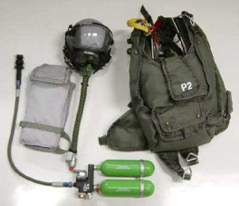  - Activity 2: Reading comprehension (CD1- track 25)  - Gives instructions  - Lets Ss listen to the recording  - Has Ss do the activity  - Checks answer  - Activity 3: Discussion  - Gives instructions  - Has Ss do the activity in group  - Gives feedback | - Respond to the T  Expected answer: an article  - Guess the topic of the article  Expected answer: extreme sport  - Listen to the T and take note new words.  - Listen to the T  - Listen to the recording  - Do the activity  - Check answers  Expected answers:  - Australia  - Malaysia  - 35km  - 14 minutes  - tied himself to the top of the speeding Porche  - Listen to the T  - Do the activity  - Listen to the T
25’ | Enjoying English: The goal of this section is to practice the language in the unit in an enjoyable, meaningful, and personalized way  - Activity 1:  - Focuses Ss’ attention on the survey and checks Ss’ understanding of the questions  - Has Ss fill in the column YOU  - Activity 2:  - Models the example conversation  - Lets Ss work in pair  - Activity 3:  - Writes the model sentence on the board  - Has Ss report what they learn about other Ss | - Respond to the T  - Do the activity  - Listen to the T  - Do the activity  - Do the activity  - Report in front of the class
30’ | Writing: The goal of this section is to practise writing a paragraph about oneself  - Has Ss read the interview and checks Ss’ understandings  - Has Ss write the similar interview  - Asks some students compare their work and gives feedbacks | - Read the email  - Do the activity  - Show the work and correct

VIII. SUMMARY OF UNIT 7: 5 minutes
- T reminds Ss about:
+ Vocabulary about extreme sports and activities
+ Present Perfect

IX. HOMEWORK:
- Ss have to do the workbook and prepare for the new lesson.

X. SELF-ASSESSMENT:
- The teaching methods are good because:
+ There are facilities and materials for students to study better.
+ The teacher’s preparation is careful.
XI. HAND-OUTS:

- I do the same thing every day. My job is very ______ . (bore)
- I have nothing to do. I'm ______ .(bore)
- My job is very varied. I find it ______ . (excite)
- I'm ______ in applying for the job. (interest)
- I heard some very ______ news. I'm going to lose my job. I feel terrible (disappoint)
- Cheer up . Don't feel so ______ . There are plenty of other jobs. (disappoint)
- I heard a very ______ story. It will make you laugh. (amaze)
- It's not ______ that you failed the exam. You never did any work. (surprise)
- My trip to Paris has been cancelled. I'm really ______ . I really wanted to go. (disappoint)
- I was ______ at the news. I didn't expect it. (amazed)

Ngày tháng năm 201
THÔNG QUA TỔ BỘ MÔN Chữ ký giáo viên

NGUYỄN THỊ MINH QUÝ Trần Thanh Trúc

Subject: English 2  Lesson plan: 9  Date of teaching:30/05/2016 | Time allowed: 2 periods | Total period taught: 51

Review: Unit 5-7

I. OBJECTIVES
This unit aims to review:
- Vocabulary: Units 5-6
- Grammar: Agreeing/Disagreeing – Adjectives with –ing/-ed – Present Perfect
- Listening: Listening comprension skill
- Reading: Reading comprension skill

II. METHOD
- Integrated, communicative oriented teaching approach.

III. TECHNIQUES
- Individual work
- Pair work.
- Group work.

IV. TEACHING AIDS
- Textbook.
- Black board, chalk.
- Cassette player, amplifier, microphone.
- Handouts to reviews old lesson

V. PROCEDURE
- Greetings.
- Checking students’ attendance: 5 minutes
- Revision of the old lesson: 10 minutes
Present Perfect: T lets Ss do the exercise on their own.
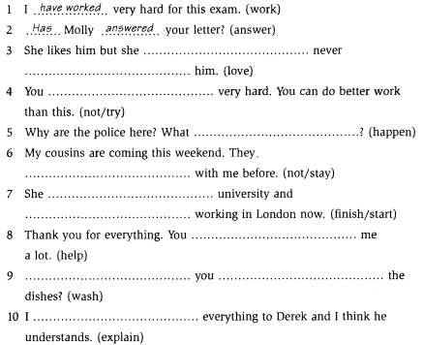

- New lesson.

 | Teacher | Students
10’ | Song: the goal of this section is to review the language presented in Unit 5-7  - Activity 1: Pre-listening  - Focus Ss’ attention on the picture and asks Ss some questions:  Where’s it?  What are there in the picture?  - Lets Ss complete the song on their own  - Activity 2: While-listening (CD1 – track 26)  - Plays the recording  - Has Ss to check their answers | - Respond to the T  - Listen to the recording  - Do the activity  Expected answers  - climbed  - crossed  - seen  - seen  - climbed  - crossed  - flown  - been  - been
20’ | Story: the goal of this section is to review and practice the language presented in Unit 5-6 in a fun way  - Activity 1:  - Focuses Ss’ attention on the comic strip and asks some questions:  Where are people?  What are they doing?  - Activity 2: (CD1 – track 27)  - Focuses Ss’ attention on the blanks and the answers choice  - Model the first one as an example  - Has Ss do the activity  - Plays the recording and checks the answers  - Activity 3: Pair work  - Asks two Ss to model the conversation  - Has Ss practice in pairs  - Activity 4: Free practice  - Shows the examples and has Ss do the activity  - Has Ss perform in front of the class  - Activity 5: Workbook  - Has Ss do the workbook P.16-19 (SC2) | - Listen to the T and answer the questions  - Respond to the T  - Listen to the T  - Do the activity  - Check the answers  Expected answers  1c– 2d – 3e – 4a – 5b  - Practise the conversation  - Do the activity  - Do the activity using their ideas  - Perform in front of the class  - Do the workbook
45’ | One-period Test

VIII. SUMMARY: 5 minutes
- T reminds Ss about main content of the lesson

IX. HOMEWORK:
- Ss have to do the workbook and prepare for the new lesson.

X. SELF-ASSESSMENT:
- The teaching methods are good because:
+ There are facilities and materials for students to study better.
+ The teacher’s preparation is careful.
XI. HAND-OUTS:
Ngày tháng năm 201
THÔNG QUA TỔ BỘ MÔN Chữ ký giáo viên

NGUYỄN THỊ MINH QUÝ Trần Thanh Trúc

Subject: English 2  Lesson plan: 10  Date of teaching: week 06/06/2016 | Time allowed: 7 periods | Total period taught: 53

UNIT 8: The best place in the world!

I. OBJECTIVES
By the end of the lesson, the students will be able to:
- Listen to a game show about world geography
- Describe places
- Read an article about Australia’s most dangerous creatures
- Write about your city
- Extend vocabulary about world geography
- Learn about superlative adjectives
- Practice word building

II. METHOD
- Integrated, communicative oriented teaching approach.

III. TECHNIQUES
- Individual work
- Pair work.
- Group work.

IV. TEACHING AIDS
- Textbook.
- Black board, chalk.
- Pictures for teaching vocabulary.
- Cassette player, amplifier, microphone.
- Pictures and hand-outs

V. PROCEDURE
- Greetings.
- Checking students’ attendance: 5 minutes
- Revision of the old lesson: 10 minutes
Present Perfect and Simple Past: T lets Ss do the exercise on their own

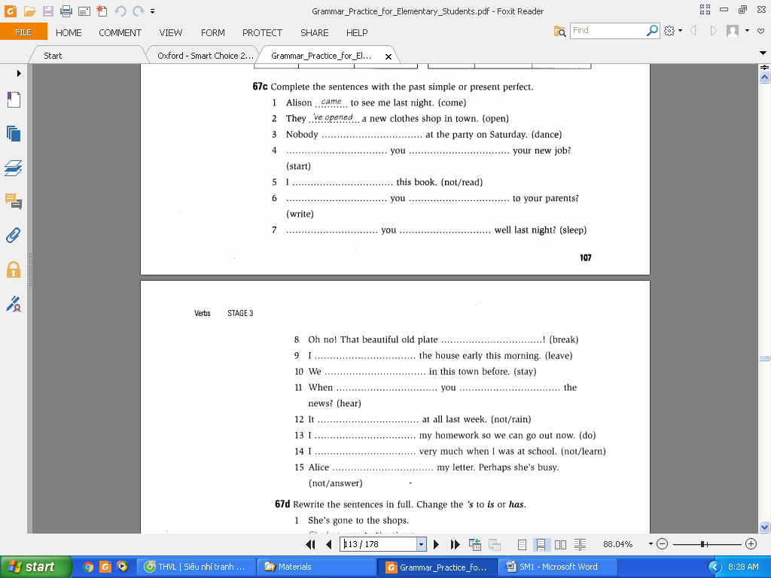

- New lesson.

 | Teacher | Students
20’ | Vocabulary: the goal of this section is to present and practice the target vocabulary of the unit  - Activity 1: Picture labeling  - Focuses Ss’ attention on the pictures and checks which words they already know  - Explains the vocabulary items that Ss don’t know and has them do the activity.  - Activity 2: Listen and check (CD1-track 28)  - Plays the recording and checks the answers of activity 1  - Activity 3: Complete the chart  - Has Ss work on their own and compare with their partner | - Respond to the T  - Do the activity  - Listen and check the answers  Expected answer  1e – 2a – 3h – 4c – 5g – 6b – 7d – 8f  - Do the activity
20’ | Conversation: the goal of this section is to present and practice the target vocabulary and grammar of the unit in a typical conversation  - Activity 1: Picture description  - Focuses Ss’ attention on the picture and asks Ss some questions:  Who are the people?  What are they talking about?  - Activity 2: Listen and check (CD1-track 29)  - Focuses Ss’ attention on the model conversation  - Has Ss do the activity  - Plays the recording and checks the answers  - Asks two Ss to model the conversation  - Has Ss practice in pairs  - Activity 3: Pair work  - Shows the examples and has Ss do the activity  - Activity 4: Free practice  - Elicits other examples of job titles and places  - Has Ss practise in pairs | - Listen to the T and answer the questions  - Listen to the T  - Do the activity  - Check the answers  Expected answers  1b – 2a – 3c  - Practise the conversation  - Do the activity  - Respond to the T  - Do the activity
70’ | Language Practice: the goal of this section is to present and practice the target grammar point  - Explain the rules  - Provides Ss with some examples  Ex:  Nam is the oldest person in the class  Quyen is the tallest man.  They are the most expensive phones.  - Elicits the meaning of the examples  - Elicits the usage of superlative adjectives  - Has Ss give examples to check understandings  - Activity 1: Completing the sentences  - Gives instructions and an example  - Has Ss do the activity  - Checks the answers  - Activity 2: Completing the conversation  - Gives instructions and an example  - Has Ss do the activity  - Checks the answers  - Workbook  - Has Ss do the workbook P.21-22 (SC2)  - Checks the answers | - Listen to the T and take notes  - Respond to the T  Expected answers  Short adj: the ADJ-est  Long adj: the most ADJ  - Respond to the T  - Listen to the T  - Do the activity  - Check answers  Expected answers:  - the deepest  - the coldest  - the most common  - the tallest  - the most crowded  - Listen to the T  - Do the activity  - Check answers  Expected answers:  - the widest - the longest  - the largest - the smallest  - the driest  - the richest - the wealthiest  - Do the workbook  - Check the answers
15’ | Pronunciation: the goal of this section to focus on the sentence intonation  - Activity 1:Listen and repeat (CD1- track 31)  - Models the examples and has the Ss repeat  - Plays the recording and has Ss practice saying the examples  - Activity 2: Pair work  - Has Ss work in pairs and do the activity | - Listen to the T and repeat  - Listen and practise saying the examples  - Work in pairs and do the activity
40’ | Listening: The goal of this section is to practise listening selectively for key information  - Picture describing  - Focuses Ss’ attention on the pictures and asks them to describe the places in the picture  - Elicits relating vocabulary using picture  Africa (n)  Asia (n)  North America (n)  South America (n)  Europe (n)  Antarctica (n)    - Listen and number (CD1-track 32)  - Gives instruction and focuses Ss’ attention on the key words  - Plays the recording and has Ss do the activity  - Checks the answers  - Listen and number (CD1-track 33)  - Gives instruction, focuses Ss’ attention on the options  - Plays the recording and has Ss do the activity  - Checks the answers | - Try to describe the pictures  - Listen to the T  - Listen to the T  - Do the activity  - Listen to the T & check the answers  Expected answers:  1b – 2a – 3c – 4b – 5c  - Listen to the T  - Do the activity  - Listen to the T & check the answers  Expected answers:  - 3.9 billions  - more than 1.3 billions  - 53  - Sahara  - 22 millions
30’ | Smart Talk:  - Reviews the questions  - Asks Ss to complete the quiz  - Gives instructions and has Ss do the activity in pairs and compare their score | - Listen and respond to the T  - Complete the table  - Do the activity
40’ | Reading: the goal of this section is to practise reading comprehension  - Activity 1: Reading comprehension (CD2- track 15)  - Asks Ss to determine the form of the text  - Focuses Ss’ attention on the title and pictures and elicits the topic  - Teaches some vocabulary  poisonous (adj): using explanation  deadly = fatal (adj) using semantic map  creature= species (n) using semantic map  venom(n) using translation  attack (v)using example  swallow (v)using example  protect (v)using example  jelly fish (n)using picture  tentacle (n)using picture    sting (v)using example  electric shock (n)using explanation  - Checks if Ss understand all the questions  - Gives instructions  - Lets Ss listen to the recording  - Has Ss do the activity  - Activity 2: True or False  - Gives instructions  - Work in pair to do the activity  - Checks answers  - Activity 3: Discussion  - Review some useful phrases such as I think…, I believe…, I have ever seen…  - Gives instructions  - Has Ss do the activity  - Gives feedback | - Respond to the T  Expected answer: a quiz  - Guess the topic of the article  Expected answer: dangerous animals  - Listen to the T and take note new words.  - Respond to the T  - Listen to the T  - Listen to the recording  - Do the activity  Expected answer:  - Taipei  - Saltwater crocodile  - Box jelly  - Listen to the T  - Do the activity  - Check answers  Expected answer:  1F – 2T – 3F – 4F – 5F  - Listen to the T  - Work in group  - Listen to the T  - Do the activity  - Listen to the T
25’ | Enjoying English: The goal of this section is to practice the language in the unit in an enjoyable, meaningful, and personalized way  - Activity 1:  - Gives instructions and has Ss do the activity in pair  - Gives feedback  - Activity 2:  - Gives instructions  - Lets Ss work in group, asking and answering questions about their town, country or the world  - Gives feedback  - Activity 3:  - Lets Ss exchange their questions with another group  - Gives feedback | - Do the activity  - Listen to the T and correct  - Listen to the T  - Do the activity  - Listen to the T  - Do the activity  - Listen to the T
30’ | Writing: The goal of this section is to practise writing a paragraph about oneself  - Has Ss read the email and checks Ss’ understandings  - Elicits Ss’ description of Denver city  How is it like?  How is the weather?  What does it have?  How are the people?  - Elicits some useful structures  - Has Ss do the activity  - Asks some students write their work on the board and gives feedbacks | - Read the paragraph  - Answer the questions  - Listen to the teacher  - Do the activity  - Show the work and correct

VIII. SUMMARY OF UNIT 8: 5 minutes
- T reminds Ss about:
+ Vocabulary about world geography
+ Superlative adjectives
+ Useful language to describe places

IX. HOMEWORK:
- Ss have to do the workbook.

X. SELF-ASSESSMENT:
- The teaching methods are good because:
+ There are facilities and materials for students to study better.
+ The teacher’s preparation is careful.
XI. HAND-OUTS:

Ngày tháng năm 201
THÔNG QUA TỔ BỘ MÔN Chữ ký giáo viên

NGUYỄN THỊ MINH QUÝ Trần Thanh Trúc

